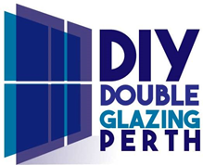
Please note that any glass combinations can be installed in your windows and all glass units have Argon Gas between the panes as standard. Eg: Obscure glass for privacy (bathrooms etc), tinted glass to reduce glare. Low-e (Low Emissivity) glass is used to improve the thermal properties of windows and doors. Laminate glass is used to enhance noise reduction. Ask us for further details for your project.
Window Opening Style Guide
There are 5 window types and some can be mixed into various combinations within a single frame. All windows are welded at the corners and contain steel reinforcements inside the profiles for maximum strength and durability. Our windows and doors are all made to measure for you.
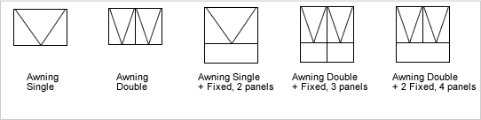
Awning windows tilt outwards rotating from the top edge. They can be fitted will all glass types.
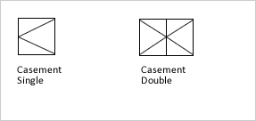
Casement windows swing open sideways. They can be fitted with all glass types and can be used in combination with Fixed, Tilt & Turn and Awning window types.
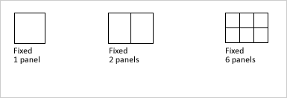
Fixed windows cannot be opened. They can be fitted with all glass types and can be used in combination with all window types.
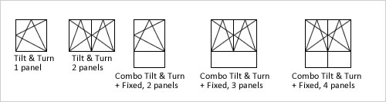
Sliding windows slide open across a fixed section. They can be fitted will all glass types. Sliding windows come in 2, 3 & 4 panel combinations.
Tilt & Turn windows are inward opening only and tilt open inwards rotating from the bottom edge and also open sideways like a regular hinged window.
