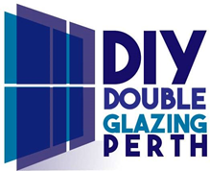
As with the windows, we can put in any glass combination required, tint, Low E, Obscure and laminate for enhanced noise reduction.
All glass combinations have Argon Gas in between the two panes of glass.
Door Opening Style Guide
All doors are welded at the corners and contain steel reinforcements inside the profiles for maximum strength and durability. All doors by law require toughened or laminated glass. All of our doors are made to measure for your project.
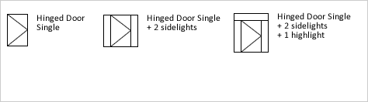
Hinged doors swing open rotating from the side edges.
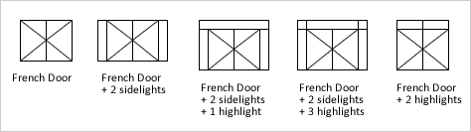
French doors swing open rotating from the side edges and always have two opening panels.
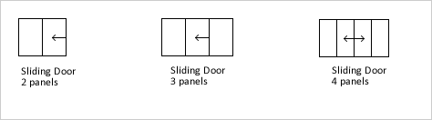
Tilt & Slide doors tilt inwards rotating along the bottom edge and also slide open like a regular sliding door. They can be fitted will all glass types. Tilt & Slide doors come in 2, 3 & 4 panel combinations
Sliding doors slide open across a fixed section. They can be fitted will all glass types. Sliding doors come in 2, 3, 4 & 6 panel combinations.
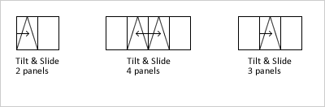
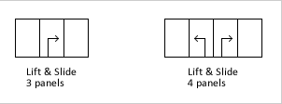
Lift & Slide doors slide open like a regular sliding door except they can be locked open in any position. This allows the window to opened a small amount for air, but not enough for a child to squeeze through and locked in that position.

